A duffer’s guide to setting up Race Coordinator to broadcast on a small wireless network
First and foremost, read section 6.3 of the current documentation (page 20) to get an overview of the settings and principles involved in this exercise.
Overview
These are the steps involved in setting RC from scratch to allow wireless (or wired if you so wish) network broadcasts of your race data to devices in the immediate vicinity.
- Download and install Race Coordinator’s latest release onto a control PC.
- Download the web pages that will be populated by RC race data onto the same PC – some of it updates can be viewed realtime, some at the end of a heat.
- Prepare the RC software to act as a web server so those pages can be viewed by a web browser
- Prepare a router (such as a BT home hub) to push out that data to a local wireless network , such as the clubroom or your race shed at the bottom of the garden.
- Set up your mobile devices, such as iPad/tablet, smart phone, wireless enabled computer, so it can read those web pages.
So the chain of events in a bit more depth will be:
- Run RC, get RC to push it’s data into a series of web files in the folder C:\Program files\race coordinator\data\html on the control PC.
- Connect that PC to a router, that doesn’t necessarily need to be connected to the internet (as you are setting up a small private network for your race event at club, or at home).
- Connect, via the wireless router, any of the devices that you want to use to view that is being created on RC, and get the device to look at the files in the folder on the control PC as mentioned above. As the race progresses, these files are modified and so the output is constantly updating.
Download files
- Got to http://www.racecoordinator.net/index.html and select the most up to date download available and install, taking all default options.
- Once this has completed, go back to the downloads section and download the latest Live Updates.zip file
- Unzip this to the directory C:\Program files\race coordinator\data It will create a subfolder \html where all your web files will live (these are the files you may later decide to jiggle with to get the race data output in the format correct for your needs – but MUCH later!).

Configuring RC for testing
In this exercise, we are going to open port 8080 on your firewall, configure RC to talk to a web server (a piece of software that is built into the RC package), run a demo race on RC, then open a web browser on the same PC and navigate to http://localhost:8080/index.html It’s pointless carrying on any more work until you are satisfied a web browser on the control PC can view realtime data, so any problems at this stage need to be resolved now.
When we are satisfied that it is displaying the data in the web browser, we can then move on to configure the wireless router and test again on a different device.
Opening port 8080 – this is covered in section 6.3 of the current readme, it is necessary to allow the broadcasting of RC data to a web page or router. Google “opening port 8080 on xyz” depending on your operating system. Disabling the firewall completely is usually not a good idea if you ever intend connecting to the internet again on this PC!
Run RC (in administrator mode in Windows 7 or Windows 8, by right clicking the icon and selecting “run as….”) and click on the options tab in the Race Day Setup page.
- Select Web Server configuration from the Options menu item
- Click “Enabled” in the Web server config box that pops up.
- Set Server Cache Size to 25 (an arbitrary figure for testing).
- 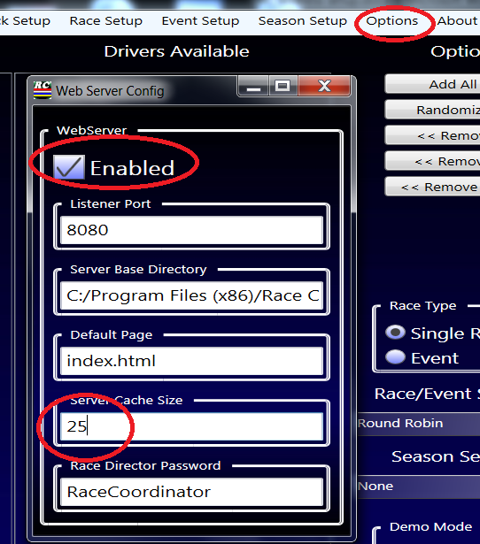
- Click the red x (top right of box) to close the Web Server configuration page.
- Select “Add all” in the options tab in Race day Setup page to populate the race with drivers
- Select Demo mode enabled in Race day Setup page
- Click start race
- The race day screen will now come up, press the space bar twice until the countdown sequence begins.
- You are now running a simulated heat.

Open your web browser of choice and type in the address bar
http://localhost:8080/index.html
and you should see a very well presented table and graph showing the four active drivers and the live race data changing as the 3 minute demo heat progresses.
You can jiggle your windows about so the actual RC application is open in one part of your screen(s) and the web page showing the transmitted data is open in another part.

All working? Then let’s pump this demo data out through a wireless router.
Configuring your router
The router doesn’t have to be wireless, you can have PCs connected directly to it by Ethernet (cat5) cables, for the purpose of the test. In fact, if you don’t have a spare router to hand, you can use your own home router for the test, although it will need a few more steps to attach wireless devices to it, as compared to a router dedicated just for the purpose.

Access the administration pages of your router:
This bit can freak some people out, as you are accessing a set of web pages that live in the router themselves. You aren’t going out to the internet, you are just running a reading device (in this case your favourite web browser) and displaying some web formatted data (in most cases the configuration html files).
Google the make and model of your router for default administrative access. Once you have the relevant account and password (usually something totally impenetrable like admin and admin) and the required IP address (usually something in the region of 192.168.1.1 or variants on the last two octets/digits), connect to the router using a network cable. There’s usually one in the box the router came in, so go dig in the garage/shed/attic if you haven’t thrown it out. Whatever you do, don’t go to curry’s or whichever one is still in business, they’ll sting you a king’s ransom for £2 or £3 worth of cable. Try the local PC mender, and tell them you need a straight through cat5 of about 2metres (really, £3 tops, ask them to ring me if they want more than that!).
Fire up a browser, type in the ip address given in your search, type in the login credentials and you should be at the home page. Go to wireless setting tab and you should see something like this:
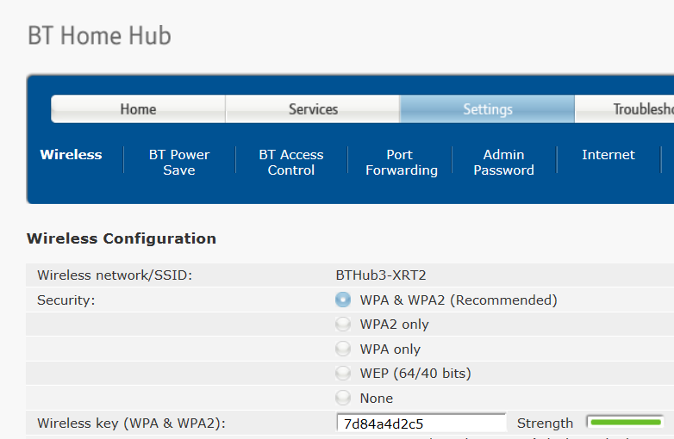
If the device is purely for RC use and is not your home hub, then set the security to “NONE”. This will allow any device to access it without having to put in the wireless key.
If you are testing on your home hub, then leave as is. Anyone wishing to connect a device to view RC data at this point would have to join wireless network BTHub3-XRT2 and enter the WPA2 key of 7d84……etc.
Whilst I was in the router, I’ve gone into advanced settings to check my IP address range. This particular router is setup to dish out IP addresses in the range 192.168.1.64 to 192.168.1.253, with the routers own IP address, as seen from our internal network, is 192.168.1.254
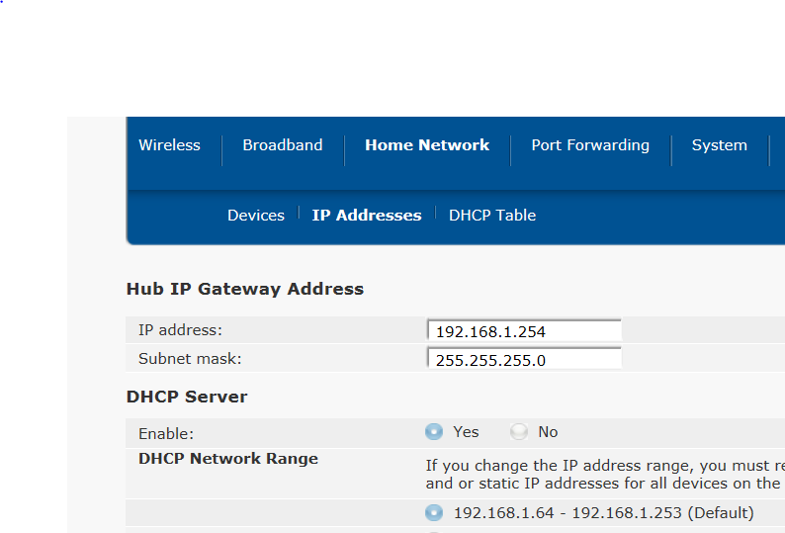
So the important action from all this, is to check your control PC has an IP address in that range.
Click start, run, cmd. This will fire up a DOS window.
At the prompt, type IPCONFIG
Look for the IP address in the IPv4 connection – it has to be in this range to allow connection to the router to transmit data out to the wireless devices.

Connect another device to the wireless network and test a demo race.
You can actually use the same PC for this test, but it’s sensible if you use another.
Make sure the device is connected to your wireless network (WLAN)
Open a browser and type in either
http://name of the control pc:8080/index.html (e.g. http://martynlaptop:8080/index.html) or
http://”ip address of control PC:8080/index.html (e.g. http://192.168.1.5:8080/index.html)
The page should come up and update as before.

Have a play, and if you have any problems, go back to basic fault finding. The steps should be:
- Have I got the firewall port unblocked? (port 8080)
- Is RC running and outputting data?
- Can I see it on a browser on the control pc?
- Have I got my device connected to the wireless router correctly?

This certainly isn’t comprehensive, but I’ve tried to fill in with a little help for a newbie. When you are in the guts of a system developing it, it’s often very difficult to unlearn all the ins and outs when trying to explain to a complete outsider how to connect to it. I’ve just tried to assist the guys that have worked very hard to get RC available to us, and then to the guys who have also worked very hard to get RC outputting data in a web readable format. They have been very helpful to me, particularly Kevin “slingshot” Gee . His girlfriend is also a very good race marshal – just need to convince her to race now.
Big pat on the back for those folks who have worked so long and hard on the product, and don’t forget, when you go live with this excellent RMS, get your donation in to Dave’s charity on his website at http://www.racecoordinator.net/charity.html

